The MySQL database system uses a client-server architecture. The server, mysqld, is the program that actually manipulates databases. To tell the server what to do, use a client program that communicates your intent by means of statements written in Structured Query Language (SQL). Client programs are written for diverse purposes, but each interacts with the server by connecting to it, sending SQL statements to have database operations performed, and receiving the results.
--------------------------------------------------
Problem:
-----------
You need an account for connecting to your MySQL server.

Solution:
-----------
Use CREATE USER and GRANT statements to set up the account. Then use the account name and password to make connections to the server.

1-→ Make Connection To MySQL server:
mysql -h localhost -u root -p

2-→ CREATING The User And Set The password:
CREATE USER 'cbuser'@'localhost' IDENTIFIED BY 'cbpass';

3-→ GRANT The Permission for The User on Databases:
GRANT ALL ON cookbook.* TO 'cbuser'@'localhost'

Note: We Can Set The host that we want instead of localhost, for example:
www.mysql.account.com

4-→ To Connect To MySQL Server from my user:
mysql -h localhost -u cbuser -p
Then Enter The password.
--------------------------------------------------
Problem:
-----------
You want to create a database and set up tables within it.

Solution:
-----------
Use a CREATE DATABASE statement to create the database, a CREATE TABLE statement for each table, and INSERT statements to add rows to the tables.

1-→ Create The Database:
CREATE DATABASE cookbook;

2-→ Change The Database To The Specified One:
USE cookbook;

3-→ Create Table Using CREATE TABLE Instruction:
CREATE TABLE limbs (thing VARCHAR(20), legs INT, arms INT);

4-→ Insert Data Using INSERT Instruction:
INSERT INTO limbs (thing, legs, arms) VALUES ('HUMAN', 2, 2);
AND ALSO WE CAN WRITE:

INSERT INTO limbs (thing, legs, arms) VALUES ('HUMAN', 2, 2), ('VALUE2', 3, 3), ('VALUE3', 4, 4);

5-→ To Check if The Insert Operation is OK:
SELECT * FROM limbs;

The Name Of Tables And database is case sensitive.
--------------------------------------------------
Problem:
------------
When you invoke mysql from the command line, your command interpreter can’t find it.

Solution:
------------
Add the directory where mysql is installed to your PATH setting. Then you can run mysql from any directory easily.

In Unix System:
mysql
mysql: Command not found.

In Windows System:
C:\> mysql
Bad command or invalid filename.

One way to tell your command interpreter where to find mysql is to type its full pathname each time you run it. The command might look like this under Unix:
% /usr/local/mysql/bin/mysql

Or like this under Windows:
C:\> "C:\Program Files\MySQL\MySQL Server 5.6\bin\mysql"

A better solution is to modify your PATH search-path environment variable, which specifies directories where the command interpreter looks for commands. Add to the PATH value the directory where mysql is installed. Then you can invoke mysql from any location by entering only its name, which eliminates pathname typing.
--------------------------------------------------
Problem:
-----------
When you invoke the mysql program without command options, it exits immediately with an “access denied” message.

Solution:
------------
You must specify connection parameters. Do this on the command line, in an option file, or using a mix of the two.

mysqldump -h localhost -u cbuser -p cookbook > cookbook.sql

Some operations require an administrative MySQL account. The mysqladmin program can perform operations that are available only to the MySQL root account. For example,
to stop the server, invoke mysqladmin as follows:
mysqladmin -h localhost -u root -p shutdown
Because the default host is localhost , the same value we’ve been specifying explicitly, you can omit the -h (or --host ) option from the command line:
% mysql -u cbuser -p

To execute multiple statements, separate them with semicolons:

mysql -e "SELECT COUNT(*) FROM limbs;SELECT NOW()" cookbook
--------------------------------------------------
Problem:
-----------
You want mysql to read statements stored in a file so that you need not enter them manually. Or you want mysql to read the output from another program.

Solution:
------------
To read a file, redirect mysql’s input, or use the source command. To read from a program, use a pipe.

% mysql cookbook < file_name

Statements read from an input file substitute for what you’d normally enter interactively by hand, so they must be terminated with ; , \g , or \G , just as if you were entering them manually. Interactive and batch modes do differ in default output format. For interactive mode, the default is tabular (boxed) format. For batch mode, the default is tab-delimited format. To override the default, use the appropriate command option.

Useful from copying database from host to host:
% mysqldump cookbook > dump.sql
% mysql -h other-host.example.com cookbook < dump.sql

The dump-and-reload example can be rewritten to connect the two programs directly with a pipe, avoiding the need for an intermediary
file:
% mysqldump cookbook | mysql -h other-host.example.com cookbook
--------------------------------------------------

Controlling mysql Output Destination and Format:
-------------------------------------------------------------
Problem:
-----------
You want mysql output to go somewhere other than your screen. And you don’t necessarily want the default output format.

Solution:
-----------
Redirect the output to a file, or use a pipe to send the output to a program. You can also control other aspects of mysql output to produce tabular, tab delimited, HTML, or XML output; suppress column headers; or make mysql more or less verbose.

Discussion:
--------------
First if we want to execute query from terminal we add:
-e "The Query Here" dbName.

To redirect The output to file: mysql dbName > outFile.

To Read From File and Make the Output to the another file:
mysql < inFile > outFile

To Send Output to another program, we can use pipe:
mysql < inFile | mail Gaafer

Producing tabular or tab-delimited output:
---------------------------------------------------
For non-interactive use (when the input or output is redirected), mysql writes tab-delimited output:
* echo "SELECT * FROM limbs WHERE legs=0" | mysql cookbook

To Display the data in table, we add -t option:
* echo "SELECT * FROM limbs" | sudo ./mysql -t cookbook
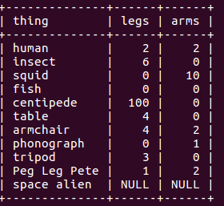

Producing HTML or XML output:
---------------------------------------------
mysql generates an HTML table from each query result set if you use the -H (or --html ) option. This enables you to easily produce output for inclusion in a web page that shows a query result. Here’s an example (with line breaks added to make the output easier to read):

sudo ./mysql -H -e "SELECT * FROM limbs" cookbook > ~/outFile.html

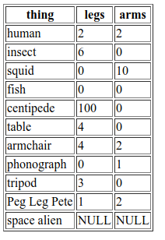

To generate an XML document instead of HTML, use the -X (or --xml ) option:
sudo ./mysql -X -e "SELECT * FROM limbs" cookbook > ~/outFile.xml

Important Note: The -H , --html -X , and --xml options produce output only for statements that generate a result set, not for statements such as INSERT or UPDATE.

Suppressing column headings in query output:
----------------------------------------------------------
Tab-delimited format is convenient for generating data-files for import into other programs. However, the first row of output for each query lists the column headings by default, which may not always be what you want. Suppose that a program named summarize produces descriptive statistics for a column of numbers. If you produce output from mysql to be used with this program, a column header row would throw off the results because summarize would treat it as data. To create output that contains only data values, suppress the header row with the --skip-column-names option:
mysql --skip-column-names -e "SELECT arms FROM limbs" cookbook

Specifying the “silent” option ( -s or --silent ) twice achieves the same effect:
mysql -ss -e "SELECT arms FROM limbs" cookbook
Controlling mysql’s verbosity level:
--------------------------------------------
When you run mysql non-interactively, not only does the default output format change, but it becomes more terse. For example, mysql doesn’t print row counts or indicate how long statements took to execute. To tell mysql to be more verbose, use -v or --verbose , specifying the option multiple times for increasing verbosity. Try the following commands to see how the output differs:
echo "SELECT NOW()" | mysql
echo "SELECT NOW()" | mysql -v
echo "SELECT NOW()" | mysql -vv
echo "SELECT NOW()" | mysql -vvv

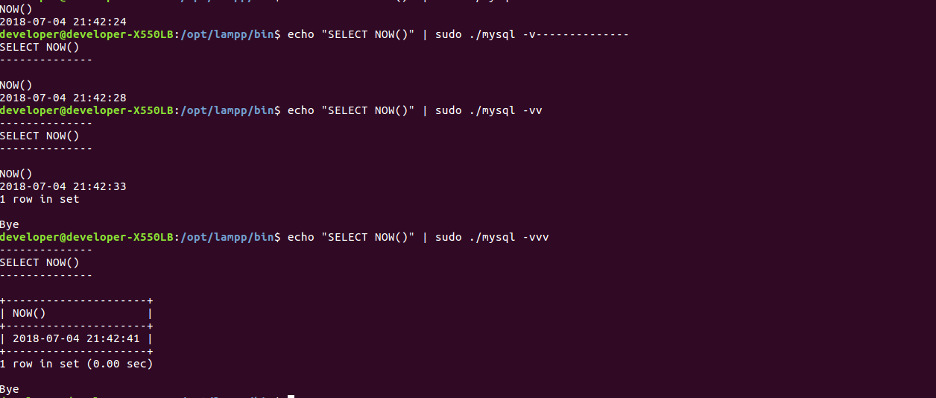
The counterparts of -v and --verbose are -s and --silent , which also can be used multiple times for increased effect.
------------------------------------------------------------
Using User-Defined Variables in SQL Statements:
------------------------------------------------------------
Problem:
-----------
You want to use a value in one statement that is produced by an earlier statement.

Solution:
-----------
Save the value in a user-defined variable to store it for later use.

Discussion:
-------------
To save a value returned by a SELECT statement, assign it to a user-defined variable. This enables you to refer to it in other statements later in the same session (but not across sessions). User variables are a MySQL-specific extension to standard SQL. They will not work with other database engines.

To assign a value to a user variable within a SELECT statement, use @var_name := value syntax. The variable can be used in subsequent statements wherever an expression is permitted, such as in a WHERE clause or in an INSERT statement.

Here is an example that assigns a value to a user variable, then refers to that variable later. This is a simple way to determine a value that characterizes some row in a table, then select that particular row:

mysql> SELECT @max_limbs := MAX(arms+legs) FROM limbs;
mysql> SELECT * FROM limbs WHERE arms+legs = @max_limbs;

Another use for a variable is to save the result from LAST_INSERT_ID() after creating a new row in a table that has an AUTO_INCREMENT column:

mysql> SELECT @last_id := LAST_INSERT_ID();

LAST_INSERT_ID() returns the most recent AUTO_INCREMENT value. By saving it in a variable, you can refer to the value several times in subsequent statements, even if you issue other statements that create their own AUTO_INCREMENT values and thus change the value returned by LAST_INSERT_ID().

Important Note: User variables hold single values. If a statement returns multiple rows, the value from the last row is assigned:

mysql> SELECT @name := thing FROM limbs WHERE legs = 0;

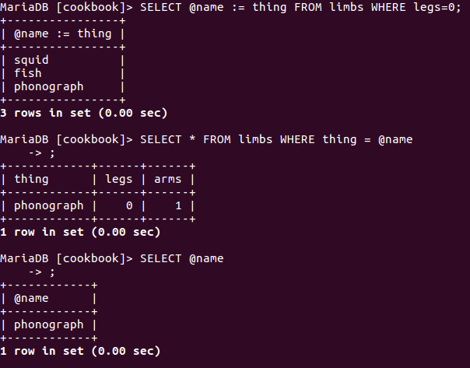
If the statement returns no rows, no assignment takes place, and the variable retains its previous value. If the variable has not been used
previously, its value is NULL :

SELECT @name2 :=thing FROM limbs WHERE legs <0;
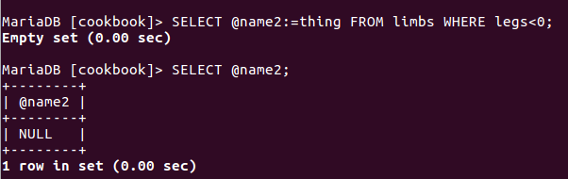

To set a variable explicitly to a particular value, use a SET statement. SET syntax can use either := or = as the assignment operator:

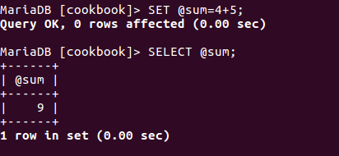

You can assign a SELECT result to a variable, provided that you write it as a scalar sub‐query (a query within parentheses that returns a single value):

mysql> SET @max_limbs = (SELECT MAX(arms+legs) FROM limbs);

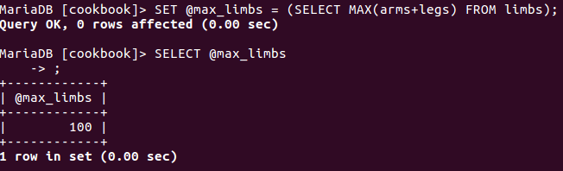

User variable names are not case sensitive:
mysql> SET @x = 1, @X = 2; SELECT @x, @X;
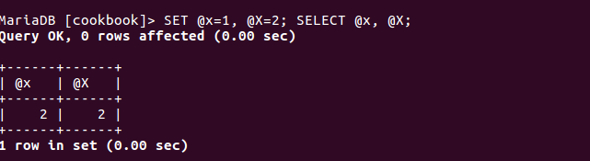
User variables can appear only where expressions are permitted, not where constants or literal identifiers must be provided. It’s tempting to attempt to use variables for such things as table names, but it doesn’t work. For example, if you try to generate a temporary table name using a variable as follows, it fails:

mysql> SET @tbl_name = CONCAT('tmp_tbl_', CONNECTION_ID());
mysql> CREATE TABLE @tbl_name (int_col INT);

